Young Badminton Player gets Training in Malaysia

S Poorvaja, MADURAI, March 16, 2015, THE HINDU
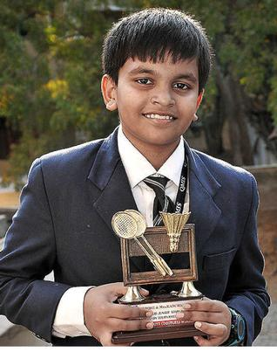
(R. Vijay Adith)
Madurai: Amidst Cricket World Cup fever that is taking sports enthusiasts by storm, a 12-year-old school student from the city has been steadily progressing towards his dream of becoming a Badminton Champion, hoping to compete in the Olympics.
R. Vijay Aadith, a Class VII student of Queen Mira International School, was recently selected to attend a one-month residential training and coaching programme at Bukit Jalil Sports School at National Sports Complex in Kuala Lumpur.
“I got to train in two phases of 15 days each and was trained by full-time Coaches there. A lot of focus was given on my strokes and playing techniques, and I picked up a lot of new strokes,” said Vijay Aadith.
The young badminton player, who currently competes in Under-13 category, has won several Singles and Doubles titles in State and National-level tournaments.
“During a student exchange programme, we happened to show his profile to Malaysian Government officials who later invited him to the School to train under the Coaches there. The School is run by the Ministry of Education and Ministry of Sports and Youth Welfare, Malaysia,” said Abinath Chandran, Director of Queen Mira School.
The budding sportsman, who currently trains at Temple City Badminton Club in Karuppayoorani, said he practised for more than six hours a day to improve his game.“I want to compete in the 2020 Olympics and bring a gold medal for my country,” he added.
------------------------------

